

**WILEY UNIVERSITY ATHLETICS**

**BRANDING  
GUIDELINES**

**2024 EDITION**

**THE WILEY WILDCAT**

The Wiley Wildcat is the official mark for the University's athletic department. It was designed during a rebrand in 2018. It was developed to symbolize our mascot's strength and tenacity and promote Wildcat pride in university marketing and communications materials. The Wildcat head with the W is the primary Athletic logo. The Wildcat head logo should be used on a Wiley Purple (Hex# 3d2c68) or black background or shape on a gray or silver background. When representing the athletics department or teams, the logo must be the dominant brand mark, which may not be coupled with other brand marks.

The Wildcat head can be used by other departments on campus but they must write Wiley University and their department next to the logo in Open Sans font.

WILEY UNIVERSITY  
**WILDCAT CAFE**



Organizations may use two lines if there is limited space. The Wildcat head with the W is strictly for promoting athletics. Neither Wildcat logos’ colors can be altered or distorted. The size may be adjusted as long as details of the logo remains clear.

**RETIRED LOGOS**

All logos that feature Wiley College or any logo except the ones previously mentioned are considered retired and should not be used in any publication representing Wiley University Athletics.



**AFFILIATION LOGOS**

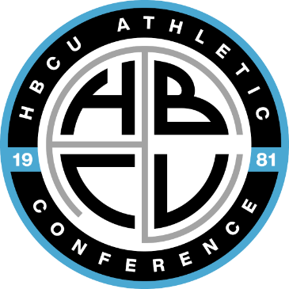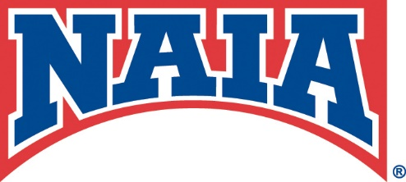The Wiley University Department of Athletics is a member of the National Association of Intercollegiate Athletics (NAIA), the Historically Black Colleges and Universities Athletic Conference and the Continental Athletic Conference in men’s and women’s soccer. The NAIA logos and conference logos can be used as secondary logos in documents, publications and graphics in content relating to the organization. The logos should be placed in the corners and sized large enough to read the text clearly but not larger than either Wiley University Athletic logo. The only circumstance in which the NAIA and conference logos can be the dominant logo is on content regarding awards from either organization. None of the logos may be altered, including changing the colors and distorting the image.

**UNIVERSITY COLOR SCHEME**

The primary color scheme for the University is Violet Indigo - **Pantone® 19-3750** (adopted as Wildcat Purple), black, and silver. There is also a secondary “accent” colors for limited use in both print and web applications. The purple accent is Purple Opulence - **Pantone® 18-3840** (Wiley Purple). The CMYK and RGB conversions for the Pantone® colors are listed to the left and the color formula for web applications.

|  |  |
| --- | --- |
| **Wildcat Purple**  CMYK: 41/58/0/59 RGB: 61/44/104 HEX#: 3D2C68 | **Wiley Purple**  CMYK: 29/42/0/44 RGB: 101/83/143 HEX# 65538F |
| **Black**  CMYK: 0/0/0/100 RGB: 0/0/0 HEX#: 000000 | Carbon  CMYK: 02/03/0/74 RGB: 65/64/66 HEX#: 414042 |
| **Silver**  CMYK: 8/6/0/24 RGB: 177/182/193 HEX#: B1B6C1 | **Gray**  CMYK: 0/0/0/65 RGB: 89/89/89 HEX#: 595959 |
|  | **Light Stone**  CMYK: 0/0/0/11 RGB: 226/226/226 HEX#: E2E2E2 |

**MEDIA GUIDELINES**

On first reference in print and broadcast media, Wiley University and the sports team being referenced should be mentioned. On second reference, Wiley is acceptable. The mascot Wildcats for male teams and Lady Wildcats for female teams can also be used on second reference if the opposing team has a different mascot name. In the case of opponents that share our mascot name, Wildcats or Lady Wildcats must be followed with of and either Wiley or the opposing school name. Wiley U is not an acceptable abbreviation under any circumstance. WU can be used in box scores only when there is limited space. The mascot name Wildcats or Lady Wildcats shall not be abbreviated as Cats or Lady Cats under any circumstances.

**FONTS**

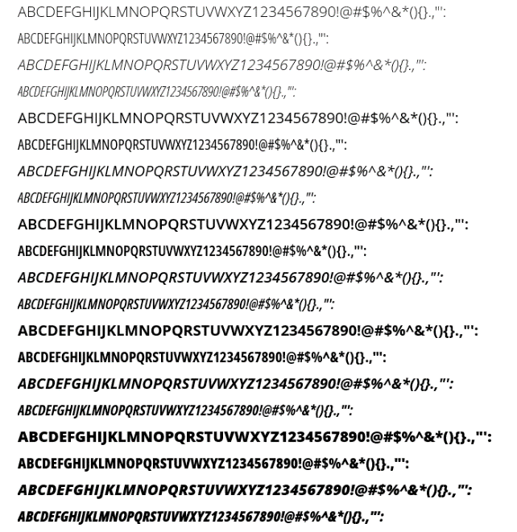 The official typeface for Wiley University is Open Sans. It should be used in all instances where typography is required. It is a simple, clean, legible typeface that complements our logo. We use four weights of Open Sans, Light, Regular, Semibold, and Bold. Any font in the Sans family, Arial and Helvetica can substitute for Open Sans on digital applications, such as websites and email. Typography shouldn't be overlooked as a critical element within our toolkit. It is crucial to adhere to this document's leading, tracking, and text arrangement to help achieve brand consistency throughout.

UNIVERSITY

The font University may be used on Athletics Graphics. It is naturally bold and works well as a header or for scores on graphics. It should not be used in any other publication. For graphics any bold font that is easy to read will also work.

**SOCIAL MEDIA GUIDELINES**

These guidelines serve as a general best-practice reference for administrators who represent various social media accounts associated with Wiley University Athletics and Wiley University and were developed by the Sports Information Director and the Marketing and Communications department, which oversees the University’s official social media presence. The purpose is to ensure social media channels represent the Department of Athletics and the University in an appropriate, authentic, safe, and genuine manner while upholding institutional core values.

University Team Social Media accounts must be created and registered in coordination with the Marketing and Communications department. The head coach of the respective team will be the account administrator and can delegate someone to run the team’s account. His contact information must be provided to the Department of Marketing and Communications. They shall have the final say on all university social media accounts. The responsibilities of account administrators are set forth here.

All aspects of account and site management, including responsibility for monitoring the site and its content, reside with the unit responsible for the account and site. Account administrators are responsible for ensuring that the site is compliant with University policies and for removing any comments or other material deemed inflammatory, vulgar, or otherwise inappropriate from the site. Marketing and Communications retain the authority of usernames and passwords and all rights to deactivate any university unit account that violates this policy.

**ACCOUNT ADMINISTRATOR RESPONSIBILITIES**

**Account administrators serve as the first responders to their unique audience through social media. While department news and event information are a top communication priority, Admins are also encouraged to:**

* Accounts will be created with a gmail address for each sport. The username will be wiley_(sport name/abbreviation). The account must be registered at the link on the marketing and communication page. This account will stay active and be passed on to future coaches. If a future coach does not want to manage a social media account(s), they will be managed by the Sports Information Director.
* The profile picture will be one of the approved athletic logos with your sport’s name or abbreviation.
* The profile should state The Official Account of (mention the Wiley University Athletics social media handle) followed by sport.
* Protect Wiley's name and brand marks. Wiley brand marks cannot be modified or used for personal endorsements, and the trademarked Wiley name cannot be used to promote a product, business, cause, political party, or candidate.
* Remain professional and in good taste, and protect Wiley's institutional voice. As a representative of Wiley University, avoid pranks and postings that could be misinterpreted. Ask your supervisor, the Sports Information Director or the Marketing and Communications department if you are unsure.
* Respect others. Social media sites are designed for two-way communication, and content contributed to a social media site may encourage comments or discussion of opposing ideas. As an administrator, you can and should respond when relevant, but consider how your response may reflect on you, your department, and the University. Ask your supervisor or the Sports Information Director, if you are unsure about posting something or responding to a comment. You may remove comments libelous or offensive by standards of the Wiley community, but do not censor posts with which you disagree. Also, avoid criticizing other people and institutions. Doing so may alienate you from your audience, reflect poorly on Wiley or escalate into a conflict.
* Connect thoughtfully. Connecting to other social media members and sites builds credibility and community and gives the unintended impression that your site endorses a specific cause, group, or person. Consider carefully whom you "friend," "follow," link to or allow into your site and to what extent you will allow comments. Help the Wiley community stay connected by linking the Wiley homepage and other Wiley social media sites. When possible, link to a Wiley University news source instead of an outside source.

**POSTING ABOUT ATHLETIC CONTESTS**

Posting about athletic contests is very crucial as it spreads word of our athletic accomplishments and keeps are community up to date on our athletic teams. It is also important to adhere to the following guidelines to maintain professionalism and good sportsmanship.

* Game Day Announcement posts should be posted at least four hours prior to the start of game time.
* For afternoon and evening games posting at 7 or 8 a.m. is recommended. For contests in the morning, posting the evening before would be best practice.
* Game Day Announcements should include opponent, date and time of contest.
* The post should also include live stats and video links for people to follow the game.
* Account administrators are to be grateful winners and losers.
* When posting about victories be excited about the team’s accomplishment but avoid rubbing it in the opponent’s face and insulting them. Also avoid violent verbs.
* When posting about a loss, find a silver lining or turn the focus towards the next contest. Under no circumstances outright criticize your coach, teammates, the officials, or opposing coaches and players.
* If necessary, the administrator can give itself time to cool off before posting.

**POSTING ABOUT COMMITMENTS**

* Account Administrators must wait until the athlete is declared eligible by NAIA Eligibility Center before posting about its commitment to Wiley University.
* For club teams they must wait until after move-in day to confirm that the athlete did come.
* Pictures posted on commitment graphics must be a clear action shot that shows the full face of the athlete or another picture that shows the athlete’s full face.
* Wiley University must be mentioned on the graphic as well as the high school or the University/university they are transferring from.

**POSTING AWARDS/REGULAR SEASON TITLES**

* Account Administrators must refrain from posting about awards until the organization publishes the winner(s) either via distributed press release, social media post or award ceremony.
* The award isn’t considered official until released by the organization.
* Account Administrators must wait until the HBCU Athletic Conference has declared its team the regular season champion before posting.
* In most instances, the race for the regular season title is tight. With most of the HBCUAC sports divided into divisions, determining the overall conference champion will be more complex. Potential tiebreaker scenarios might need to be reviewed
* In the sports of cross country and track and field, they will need to wait until after the award ceremony before posting. This will allow all challenges to be resolved.
* Postseason matchups cannot be posted until the organization hosting the tournament has published the bracket.
* Pay attention to what time zone is posted, especially in NAIA postseason games. See chart below for time differences.

|  |  |
| --- | --- |
| Atlantic Standard Time | 2 hours earlier |
| Eastern Standard Time | 1 hour earlier |
| Mountain Standard Time | 1 hour later |
| Pacific Standard Time | 2 hours later |

**BIRTHDAY AND HOLIDAY POSTS**

* Athletes’, coaches’ and administrators’ birthdays and holiday social media posts will be done solely by the Sports Information Director.
* All team accounts will be added as collaborators on holiday posts. The team account(s) that the athlete represents will be added as a collaborator on birthday posts.

**GRAPHICS/IMAGES**

* All graphics that are published must be in the approved colors of the University Color Scheme.
* Wildcat Purple must be the background color or main accent color.
* All images used on graphics must be in focus and zoomed in on the subject.
* Wiley University must be somewhere on the graphic
* One of the approved Wiley University Athletics logos must be the dominant logo on the graphic
* All pertinent information must be on the graphic.
* If you are using a dark background, use light colored text and vice versa
* Other details can be put in the caption of the social media post
* All images posted on Wiley University Athletics accounts must be in focus and at least a profile of the athlete is visible.
* If using cutouts, all of the background must be removed.
* The athlete cannot make any gestures that would be deemed offensive
* Photos depicting drug use or sexual nature are strictly prohibited.

**VIDEOS**

* The subject and action in videos must be in focus and steady.
* Subject(s) must avoid using profanity or making obscene gestures
* If shooting locker room video all subjects must be dressed.
* Videos on social media should not be longer than 90 seconds.

**TAGS, MENTIONS, ADDING COLLABORATORS**

* All Wiley University Athletics team accounts will add @wileyuniversityathletics as a collaborator on all posts.
* All Wiley University Athletics social media accounts will add @wileyUniversity1873 as a collaborator on the following items:

1. Conference Regular season and Tournament Titles
2. NAIA Postseason victories
3. NAIA All-American Recipients
4. Head coach hires
5. Academic Award winners

* Account administrators can tag the opposing school on Game Day Announcement posts and final score posts
* Athletes can be tagged on all social media posts that they’re featured in as long as their handle isn’t vulgar or obscene.

**OFFICIAL HASHTAGS**

* The official hashtag for Wiley University Athletics is #FeartheClaws and should be used on every post by a team account.
* Go Forth Inspired is Wiley University’s tagline and should be used as a hashtag on all posts.
* #WhereWinnersThrive is the official hashtag of the HBCU Athletic Conference and should be used on all social media posts even if the sport isn’t sponsored by the conference.
* Teams may create their own hashtags but must include the previous mentioned hashtags on social media posts.

**FREQUENCY OF SOCIAL MEDIA POSTS**

* No Wiley University Athletics team account should post more than five times per day.
* Account administrators should allow at least two hours in between posts.
* Game Days can be the exception to the previous mentioned rule. No more than 10 posts on that day and no more than five during the time the event is taking place

**ATHLETIC WEBSITE**

* The Athletic website provides news on Wiley University’s teams and the department as a whole.
* Pictures posted on the website must be in focus and at least a profile of the athlete should be visible.
* Graphics used with articles must be well designed and complement the article.
* Administrators which include the director of athletics, associate athletic directors, the administrative assistant, sports information director, faculty athletic representative and the athletic trainer should wear either an athletic polo or business attire for their profile pictures.
* Coaches may wear game day attire, athletic polo or business attire.
* Athletes may wear their uniform, warm ups or team polos.